Table of Contents

- What is the value proposition and business model for the site?-----------------------------------------------2
- Who are their competitions?---------------------------------------------------------------------------------------------2
- How does the website integrate with other channels?-----------------------------------------------------------2
- Who are the intended customers for the website?----------------------------------------------------------------3
- How does the site market and advertise in order to attract consumer interest? (Attract)-------------3
- What type of tools and features does the site provide to enhance customer experience? Consider how the site applies web 2.0 tools and personalization?--------------------------------------------------------4
- How does the site attract different types of customers such as impulsive, patient and analytical buyers? (ATTRACT)---------------------------------------------------------------------------------------------------------5
- How does the site process order placement and payment? (ACT)--------------------------------------------6
- How does the site handle delivery, shipping and returns? (ACT)----------------------------------------------6
- How does the site maintain customer service and support? (REACT)-----------------------------------6
- How useful is the site’s special interface feature and arrangement of content?---------------------7
- Describe how the site provides a utilitarian and hedonic shopping experience?--------------------8
- What are some possible improvements or enhancements you would recommend in order to improve customer loyalty?-----------------------------------------------------------------------------------------------8
References -------------------------------------------------------------------------------------------------------------------------8

- What is the value proposition and business model for the site?
The business model of Safeway.com is to meet the needs of busy consumers who prefer the flexibility of shopping online at any hour of the day and the time-saving convenience of home delivery. This extension of Safeway's business into the home delivery channel provides consumer with an exceptional, convenient service.
Today’s job demand and work environment have become so competitive that most of the people do not really have to do things like grocery shopping. Consumers are busier than ever, more mobile, more affluent, and increasingly impatient with mundane time-consuming tasks. Safeway acts as an agent of convenient, dependable alternative solutions for repetitive but necessary task.
- Who are their competitions?
Safeway has number of competitors. Their major competitors are as follows:
- Gourmet Grocery Online
- NetGrocer.com
- Shopping.com: Food & Drink
- Amazon.com: Gourmet Food
- AULSuperStore.com
- Schwans.com
- Shop Natural
- YourGrocer.com
- Peapod Online Grocery Shopping

3.0 How does the website integrate with other channels?

Safeway has a wide range of products. Their major strength is they partner with high quality brands to provide low prices products throughout their stores.

The list of brands available at Safeway:
- mom to mom
- Safeway SELECT
- Signature Cafe
- Priority® Pet Care
- Basic Red
- Primo Taglio
- Rancher's Reserve
- Lucerne
- Bright Green
- waterfront BISTRO™
- Safeway Brand
Safeway do not do their advertising themselves. They hired DDB, a Chicago based advertising agency and PHD, a San Francisco based company to handle their retailer’s advertising, media planning and buying in 2006.
4.0 Who are the intended customers for the website?
The intended customers of safway.com are categorized into three different groups. They are:
4.1 Busy and time starved Consumers: Safeway’s major customers seems to be the busy and time starved ones who do not have time to visit the store every week for their grocery shopping.
4.2 Consumers who find grocery shopping mundane and stressful activity: Some consumers find grocery shopping mundane and stressful activity because of crowding and queuing. Crowding and queuing is disliked because it frustrates customers achieving their task as easily as they would like.
4.3 Consumer with disability: Consumers or individuals with disabilities related to age or health are other prominent customers for Safeway. It is obvious that disabled or elderly consumers have difficulty in shopping in traditional environment.

5.0 How does the site market and advertise in order to attract consumer interest? (Attract)

Safeway.com advertises through number of different channels. Most of the advertisement is done through traditional medium such as television, banners (in-stores and off stores), leaflets etc.

Safeway also values the importance of social media. They have their own facebook account with 72,517 fans. Link to their facebook account could be seen on their website. Their facebook page provides general overview of the company and lists all the brands they have in their stores. They also have a tab labeled “savings” with weekly offerings and savings information.

As mentioned above Safeway hires advertising agency to promote its brand and services.

6.0 What type of tools and features does the site provide to enhance customer experience? Consider how the site applies web 2.0 tools and personalization?
Some of the tools and features enhancing customer experience are as follows:
- Weekly Specials: On the home page of the site, users can quickly enter their zip code and find weekly specials at their local Safeway stores
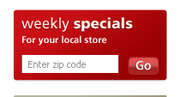
- Shopping History: Registered users can view their shopping history and can order the same products again. This allows users to save their time from doing the same repetitive task (if they wish to buy the same products again).

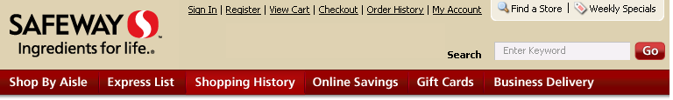
- Express List tool: The Express List tool allows users to type in their shopping list, search for products and quickly checkout. This allows user to save time of going through each product and putting them into basket individually.
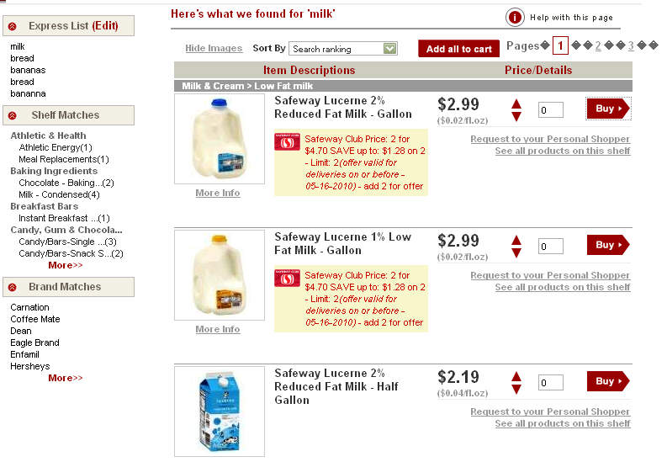
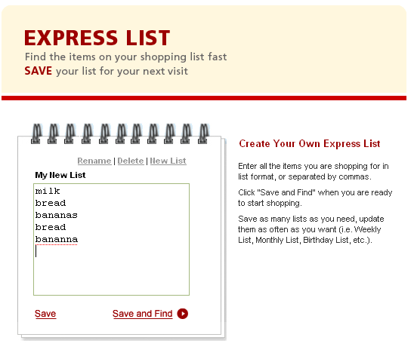

Search result of items in the express list
7.0 How does the site attract different types of customers such as impulsive, patient and analytical buyers? (ATTRACT)
There seem to be a lot of effort being made to attract the patient customers on the site. Lot of special offers and saving options are provided on the home page. Users or customers can get emails about special offers after signing up for the facility.

Users can also quickly view the weekly special deals at their current location. This is exactly what patient customers look for.
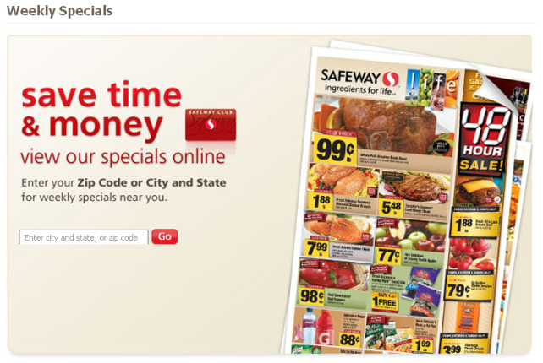
Customers can also print coupons or load coupons to their loyalty card and get discount on items.
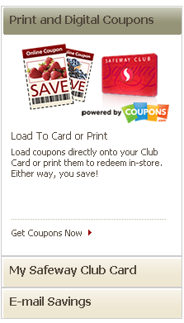
I couldn’t find any features in the site for attracting impulsive buyers. No recommendations are made based on user’s previous purchases or their shopping cart.
Most analytical buyers would like to compare the prices of the product they wish to buy. The website does not compare their prices with other online retailers. So there don’t seem to be any facilities for analytical buyers. But like mentioned above there are various information on special offers and coupons with which consumers or users can save money.
8.0 How does the site process order placement and payment? (ACT)
Users will have to enter their username (email) and password to place an order. New users will have to register with the site before putting products in their shopping list. It is not necessary to register, if the user just wants to browse through the site. He/she can simply enter their zip code on the right hand side of the Sign in page and start looking for products using the Search tool.
The simplest way of placing the order is by using the search tool which could be seen at the top right corner of every page. If the user or customer has a shopping list, he or she can simply type in all the products at once using the Express list tool and click the “Find Now” button. Users can also browse through products using the Shop by Aisle feature.
Unfortunately, the shopping cart is not as good as I expected. Event though the running price is displayed on top of the screen, user has to select the “View Cart” to see the list of products in their shopping cart.
There is also an option for frequent buyers to view their shopping history and purchase the same list of products again with just a single click.
The web site uses a frame-based technology OR Secure Socket Layer (SSL) technology. It could be verified by right clicking inside of the picture of the credit card and choosing the properties option. The URL address line will show the https:// you are looking for.
9.0 How does the site handle delivery, shipping and returns? (ACT)
Safeway uses their own van to deliver products. Customers are allowed to return items if they are dissatisfied with the quality of the products or if they receive incorrect products or items in their bag.
If the driver is present, the customer can notify him or her on any unwanted products. The driver will return the product at the store and the customer’s credit card will receive a fund. If the driver is not present, customers will have to contact the Customer Service department within 48 hours from the time of delivery with issues pertaining to the order.
There are certain products that Safeway does not allow customers to refund. Items like alcoholic beverages, baby formula and tobacco products cannot be returned once purchase is made online.
10.0 How does the site maintain customer service and support? (REACT)
Like mentioned above, Safeway provides a great customer service by allowing its customers to return unwanted products either with the delivery person or by calling the customer service which is open 24 hours a day.
Customers are allowed to track their orders and even allowed to reschedule the delivery time prior to 3:30 am for deliveries between 10:00 am & 3:00 pm deliveries or before 8:30 am for deliveries between 4:00 pm & 9:00 pm.
11.0 How useful is the site’s special interface feature and arrangement of content?
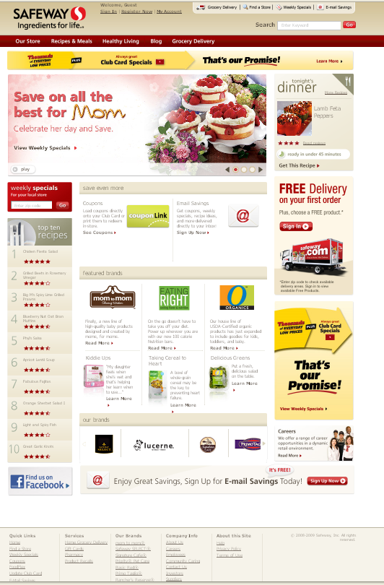
This is the home page of safeway.com. There is lot of elements in this page, yet it does not look so cluttered.
The main navigation buttons are labeled cleverly and are very meaningful. I didn’t struggle to find out its purpose or its meaning.
The “Save” text is being used all over the page. It seems like Safeway is giving a message that, “You Can Save money here”.
There are also some elements of stickiness in this page. The Recipes and meals and healthy living section of the site are attempting to keep users in the site and hopefully come back for more.
The bottom links on this page provides quick links to the important elements of the site, services they provide, information of the brands they have in store and the company overview.
Overall the site and its content seem to be arranged perfectly.

12.0 Describe how the site provides a utilitarian and hedonic shopping experience?
The desired outcome of a utilitarian shopping is most often a purchase from the website. Anything that gets in the way of completing the purchase would dissatisfy the customer because something got in the way of that process. Most of the time utilitarian shopping experience could be provided effectively with improving the technical aspect of the website. Safeway provides a great utilitarian shopping experience to its users. When tested, all the links and navigation buttons were working fine and the shopping cart was also correctly displaying the running cost.
The hedonic shopping experience of the user is concerned more with the aesthetic aspects of the website. I think the shopping experience of Safeway website is very enjoyable and informative at the same time. The interface is clean and the navigation buttons are very intuitive. During the shopping process, the website informs user of a reduction price on items in the cart. This is a great way to satisfy users need for “discovering” a bargain and potentially motivate them to buy rather than to abandon.

13.0 What are some possible improvements or enhancements you would recommend in order to improve customer loyalty?
The delivery charge of Safeway looks very expensive. I believe it would be a great gesture to provide free delivery service to customers who spend certain amount of money every week and for customers who have been with them for certain number of years.
I would also like to be able to use the “Express List” functionality without being a member of the site. Currently, unregistered users are asked to enter their user name and password to use this functionality. Sometimes, users might just like to quickly find out if the site has items they are looking for. Express list gives that functionality to users but sadly only to the registered users.
Like mentioned in section 8, the shopping cart is not that great. The user has to select the “View cart” link to check the list of products in the shopping basket. If they wish to continue shopping they will have to go back to the page again. It would be convenient for users to have the cost and product list displayed somewhere at the left hand side of the page.
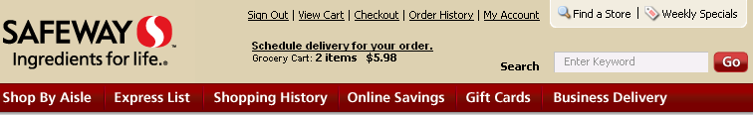
Shows the running total but to view the items in the shopping cart users have to click the “View Cart” link.

References:
- http://www.safeway.com/IFL/Grocery/Shopping-Help-Price-Promotions
  - Help and FAQ’s
- http://www.safeway.com/IFL/Grocery/Home
  - Safeway homepage
- Paden,Nita (February, 2010),“Virtual Cart Abandonment: Addressing Hedonic and Utilitarian Shopping Motives”, [online], Available at: http://asbbs.org/files/2010/ASBBS2010v1/PDF/P/Paden.pdf
- Vigoroso.W.M (March, 2002), “Safeway Fires Back in Online Grocery Battle”, [online] Available at: http://www.ecommercetimes.com/story/16772.html
- Progressive Grocer (August, 2006), “Safeway Picks Agency Partners for $250M Marketing Push”, [online] Available at: http://www.allbusiness.com/retail-trade/food-stores/4262014-1.html

